**Yellow tag tool safety guidelines**

**Injuries  
  
If a SERIOUS injury should occur, the uninjured person must  
  
1) Turn off all tools and equipment.  
  
2) Dial 911 by cellphone or 6911 from a lab phone. The TIES building address is 1150 Mendocino Ave.**

**3) Notify everyone in the TIES lab that there has been an accident. Everyone must stop working on their projects until the situation is resolved.**

**3D Printer:**

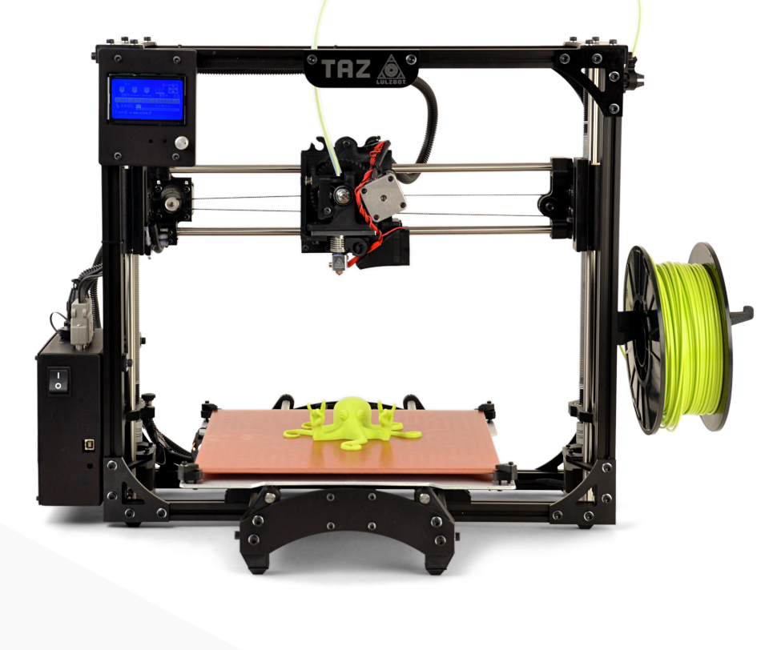

* **Never print a lower temperature filament after a higher temperature filament without completely cleaning the print head.**
* **The tip and freshly extruded plastic are very hot.**
* **There are moving parts with pinch points. Keep fingers out of the way while the printer is running.**
* **When printing with ABS, the print bed will be 110C, allow it to cool before removing the print.**
* **Be very careful removing your print from the print bed using the knife. Always push away from yourself and never place your other hand in the path of the blade.**

**Vinyl Cutter:**



* **Allow some slack in the vinyl as it is fed off the roll in the back of the cutter.**
* **The cutting tip is extremely sharp. Ask a technician if adjustment is needed for thicker or thinner materials**
* **Insert material to be cut and adjust rollers to fit material.**
* **Calibrate the software canvas to the actual size of the material loaded in the cutter.**
* **Remember to re-set the origin before starting the next cut.**

**Hot wire foam cutter:**

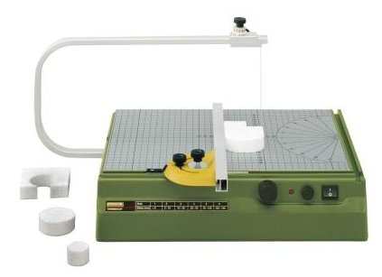

* **Never leave the foam cutter turned on when unattended.**
* **The wire is very hot.**
* **Do not force the foam as this may break the wire.**
* **Unplug the foam cutter before changing the wire.**
* **Adjust the temperature setting as appropriate for the foam and rate of cutting.**

**Electronics station and soldering iron:**

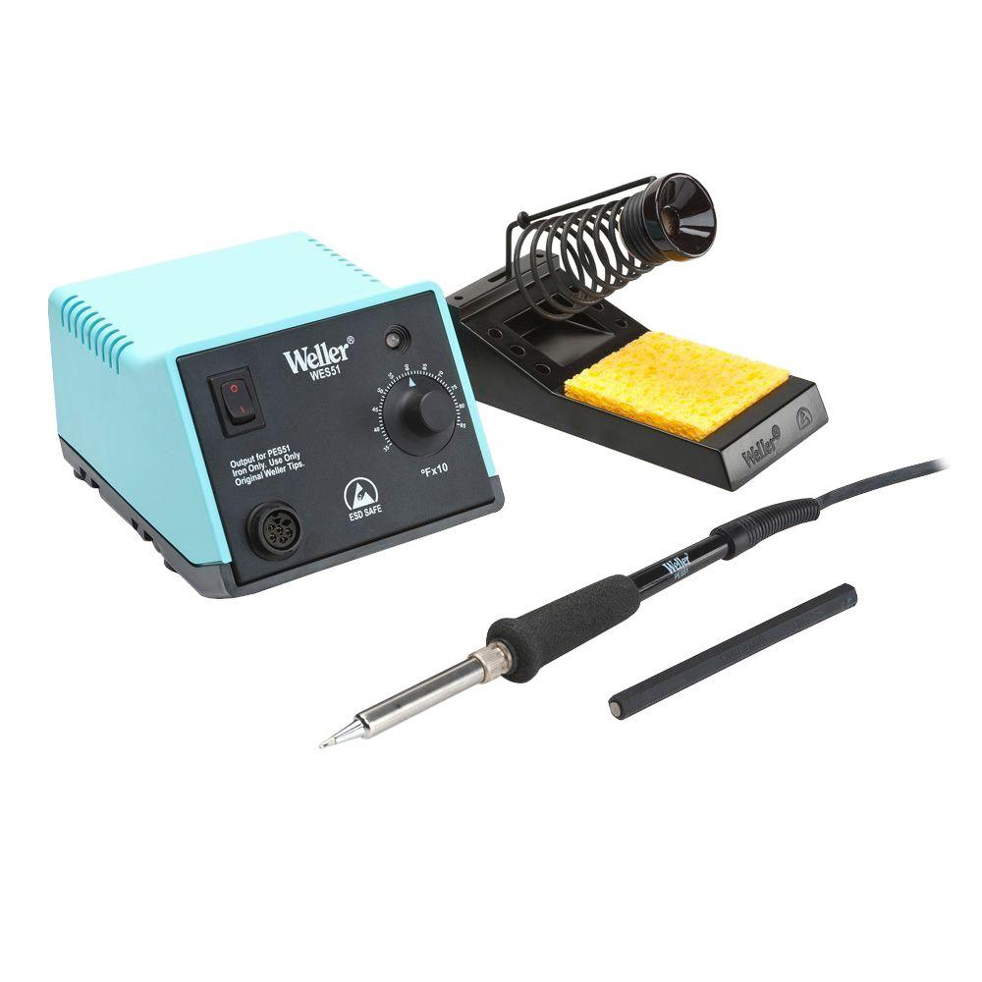

* **Soldering allows one to physically and electrically connect two metal nodes with solder, a combination of metals that melts at low temperature.**
* **Always treat the soldering iron as if it is HOT! When you arrive at the station, you do not know how recently someone may have used this tool.**
* **Soldering irons can cause severe burns, so it is important to be vigilant and not lay the tools out or reach for them indiscriminately. ALWAYS turn them off after use!**
* **NEVER solder on plugged in electronics.**
* **Even unplugged electronics are not guaranteed to be safe. Batteries and capacitors function to store energy and can still provide dangerous shocks. Always understand and be conscious of what you’re working on!**

**Sewing Machine:**

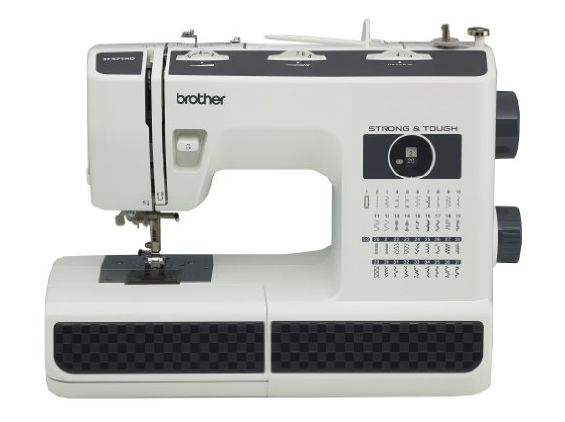

* **Turn off and unplug the machine before threading the needle or loading a bobbin.**
* **The machine is foot activated. Make sure the area around the footswitch is clear before turning on.**
* **Never sew with a bent needle. Ask a technician if you need assistance with changing a bent needle or to a twin needle setup.**
* **Lower the presser foot lever before starting a stitch.**
* **Always be very cautious of the plane of the needle. Keep your hands out of the plane and be cautious of the material moving through the machine**

**Hammers/mallets:**

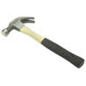 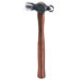

* **Never strike two hammer heads together, they may shatter.**
* Use soft mallets for positioning.
* Use claw hammers for carpentry.
* Use ball pein hammers for metal work.
* Use an appropriate type and size hammer for the job.
* **Make sure that the hammer head is securely attached to the handle before using.**

**Chisels and Punches:**

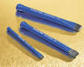

* **The direction of cutting should be away from you.**
* **Wear a Face Shield when using a chisel.**
* **Plan where the chiseled parts will fly and take precautions to protect others.**
* **Don’t use chisels with a “mushroomed” head, have a Tech grind it off.**
* **Use the appropriate chisel for wood or metal.**
* **Drive a wood chisel with a mallet.**
* **Drive a metal chisel or punch with a ball pein hammer.**

**Saws:**

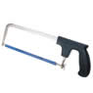 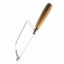

* **Coarse teeth are for “soft” materials. Fine teeth are for “hard” materials.**
* **Hacksaws are for metal, wood saws are for wood.**
* **At least three teeth must span the thickness of the material to be cut.**
* **Don’t bounce the blade on the material being cut**
* **Keep hands out of the plane of the blade.**
* **Keep hands on top of the material and visible.**
* **Start and end your cut gently for accuracy.**

**Vise and Clamps:**

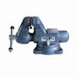 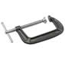

* **Don’t over tighten them, you may damage the part or the tool.**
* **Don’t ever use “cheater bars” or hammer on the handle.**
* **Hold round stock securely with a “Vee block” in a vise.**
* **Make sure the setup is stable and secure before working.**
* **Use “soft jaws” to hold soft materials without damage.**

**Screwdrivers:**

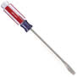 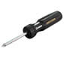

* **Use the correct type and size that fits the fastener:**
* **Flat Blade/Standard (straight blade)**
* **Phillips (x-shaped)**
* **Torx (star shaped-6 points)**
* **Allen or hex (fits into a hexagon shaped hole)**
* **Nut Driver (fits over hexagon shaped nut)**
* **Never use a screwdriver as a chisel or prybar.**
* **Don’t use a screwdriver if the tool tip is worn or damaged.**

**Tap and Die sets:**

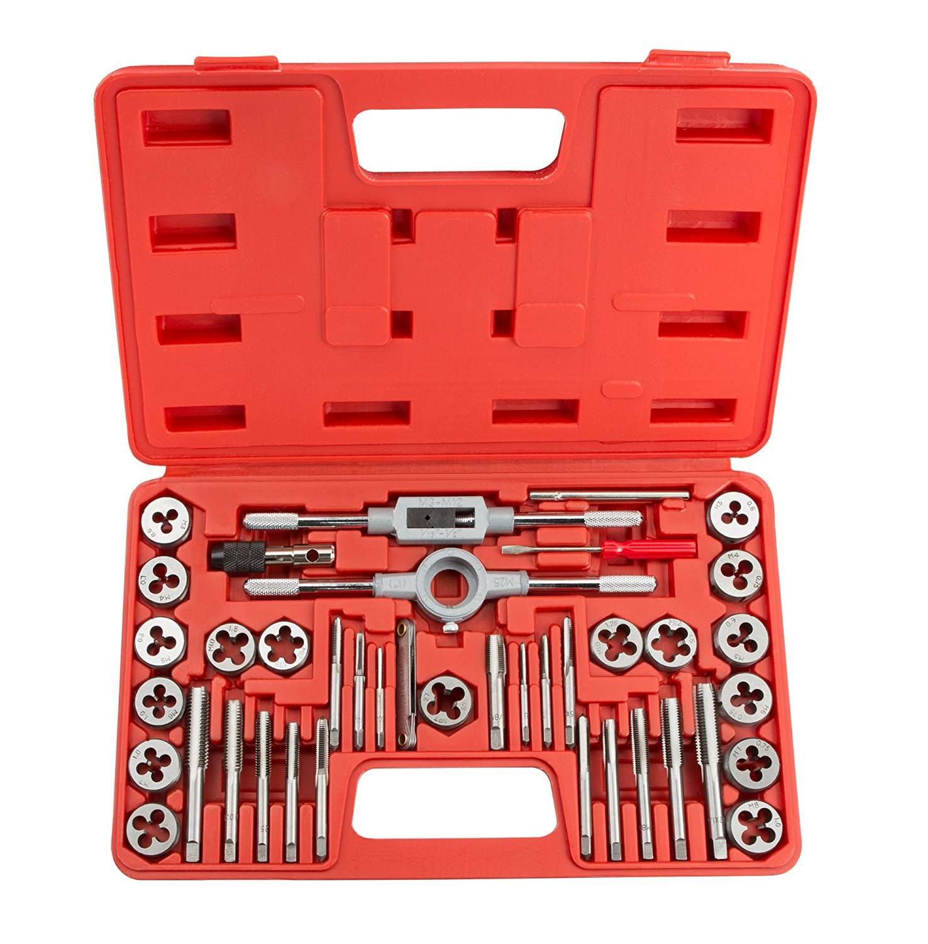

* **Taps and dies function to put threads (the mechanism by which nuts and bolts tighten and loosen) on the interior of a metal hole, or the exterior of a metal cylinder, respectively.**
* **Securely clamp your workpiece.**
* **Always use tapping fluid to prevent metal-to-metal contact.Starting the threads is always the hardest part, and requires practice. You will need about two turns to get the threads started. Past that point, you must only descend 1/4 turn at a time, backing out to clear away material chips each time. If you try to cut too deep without clearing the chips, the channels will get so full of chips that the tap or die will get stuck on the workpiece. If you try to force it farther, it will break the tool. When you perform the tapping/dieing correctly, you should never need to use excessive force**

**Sheet metal shears and tin snips:**

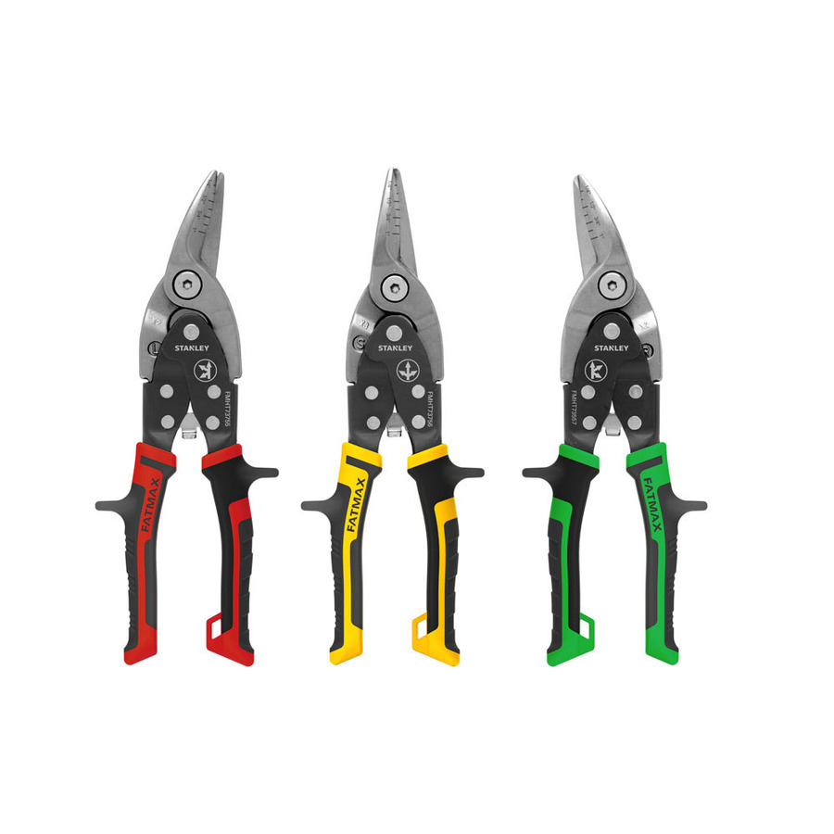

* **These tools function to cut through various types of thin (high) gauge sheet metal.  
  When using these tools, always wear gloves. The edges of the sheet metal are extremely sharp, both before and after cutting.**
* **And of course, don't force!**
* **Do NOT use tin snips to cut wire or nails! You will dull the blades at a particular spot. Then, every time you try to cut sheet metal, you will get stuck there. Use wire cutters and-or bolt cutters as appropriate to cut wire and/or nails.**
* **Workpieces should be clamped or held tightly.**
* **Tools should always operate easily and under control.**
* **Tools are designed to make it easier. If you're straining to get the job done, you’re probably using the wrong tool or process. ASK!**

**Pliers:**

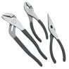

* **Use them to grip surfaces and objects with irregular shapes.**
* **Don’t use them on parts with “flats” (i.e. nuts, bolts, plumbing valves, precision parts), as they will damage the surface.**
* **Don’t grip them with your fingers between the handles, as they will be pinched if the tool slips.**
* **Keep the jaws parallel or the handles close together for the safest grip.**
* **If the part is too big, use a pipe or strap wrench.**

**Wrenches:**

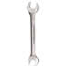 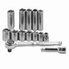

* **Must fit the part snugly to prevent stripping the part or slipping and injuring you.**
* **Pull towards yourself, don’t push, for safe control.**
* **Don’t use extensions or “cheaters”, you will break or bend the tool.**
* **Don’t ever hammer on the handle.**
* **The movable jaw of a Crescent wrench must face the direction of rotation.**
* **Never use pliers or pipe wrenches on parts with flat sides, ie. bolts/nuts.**
* **Clamp or hold workpiece securely.**

**Knives:**

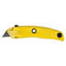 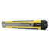

* **Cut away from yourself and others.**
* **Don’t use dull blades.**
* **Retract or close the blade when done.**
* **Don’t hit or strike them with anything.**
* **Do not use them to pry anything.**

**Files:**

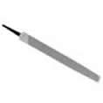

* **Must always have a handle on the tang (pointy) end.**
* **Don’t store them rubbing together, they will dull quickly.**
* **Never use them as a prybar or hammer, they are brittle and will break.**
* **Don’t run your hand over the surface you’re filing – your body oils slow down**
* **the cutting action and you could get slivers.**
* **Clean soft metals from them with a “file card” (a special metal brush) immediately after use, or when they get clogged.**
* **Use chalk to prevent clogging by soft metals such as brass or aluminum.**

**Measuring Tools:**

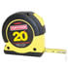 

* **Retract tape measures slowly to avoid breaking the tape.**
* **Don’t ever use calipers to scribe lines as this will ruin the ends of the jaws.**
* **Scribe lines with scratch awls or dividers.**
* **Keep measuring tools clean.**
* **Don’t mark up or abuse rulers or use them as hammers, prybars, etc.**
* **Handle calipers and micrometers with care, clean measuring faces between uses with your clean fingers or a sheet of paper.**
* **Clamp measuring tools gently for accuracy and to prevent tool damage.**

### **Powered Hand Tools:**

* **Never use a power tool if you are tired or under the influence of drugs, alcohol, or medication.**
* **Before using, inspect the cord for missing prongs, frays, cuts, and other damage. Cordless tools should be inspected for damage to the battery. A cracked or swollen battery pack should be reported to a shop technician immediately.**
* **DON’T use a tool if the cord or battery is damaged or the tool makes funny sounds etc. , ask technician for help.**
* **ALWAYS Unplug or remove the battery pack of the tool to change bits, blades, etc.**
* **Remove chuck keys and tightening tools IMMEDIATELY. ( i.e. as soon as you are done with them.)**
* **Make sure that the RPM (speed) of the tool does not exceed the rating of the bit, wheel, blade, etc. that you use. Otherwise, it may fly apart causing damage or injury.**
* **Wire brushes often throw wires, wear Safety Glasses and a Face Shield and protect others around you.**
* **Don’t put the tool down until the motor completely stops.**
* **Watch what’s on the other side of what you’re drilling or cutting, and don’t put your hand there.**
* **Use a Face Shield *and* Safety Glasses when working with materials or tools that may throw debris, especially high-speed tools like routers.**
* **Don’t wear loose clothing, jewelry or gloves; tie long hair out of the way. (Note; Gloves may be acceptable in some circumstances, ask permission to use them with any power tool).**
* **Use the proper dust mask or respirator when working on dust or fume producing materials.**
* **Use the fume hood if making fine dust or using solvents.**
* **Let the tool do the work. Don’t exceed the capacity or force the tool.**
* **Be aware of fire or burn danger when using soldering tools or heat guns. Always place hot tools and objects on a non-flammable surface.**

**Heat gun:**

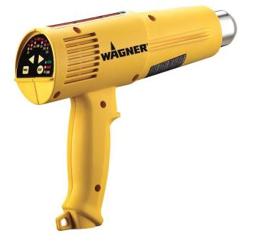

* **Never leave the heat gun plugged in when unattended.**
* **The tool has an automatic cool down feature, do not set the tool down until it has completely shut off.**
* **The gun can reach temperatures that will ignite paper or plastics.**
* **Always treat the heat gun with the same respect as an open flame.**
* **Do not touch the nozzle until the tool has cooled completely**

**Hot glue gun:**

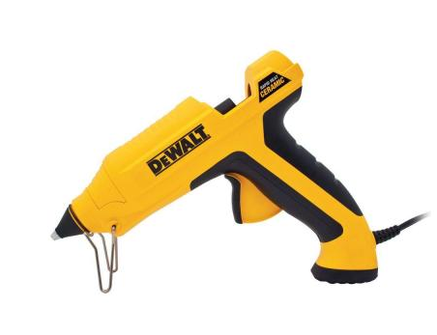

* **Never leave the glue gun plugged in when unattended.**
* **The tip and glue are very hot.**
* **If you get hot glue on you it will stick and continue to burn, immediately run cold water over the area.**

**Dremel multi tool:**



* **Always wear safety glasses. A dust mask is recommended. Preferably use where dust and particles won‘t be an issue ie. in the hood.**
* **Keep bystanders away or ensure they have proper eye protection.**
* **Never leave the Dremel multi tool plugged in when unattended.**
* **Stay alert, watch what you are doing and use common sense when operating this and all power tools.**
* **Grip the tool firmly during startup, the tool can generate surprising torque and slip out of your hand.**
* **Never start the tool when the bit is engaged in the material.**
* **Whenever practical clamp the workpiece to a table or in a vice, maintain at least 6” between your hand and the spinning bit.**
* **Avoid placing yourself in the plane of the spinning wheel. Small particles, wire fragments or wheel pieces can be discharged at high velocity and embed themselves in skin etc.**

**Dremel Drill Press Mount:**

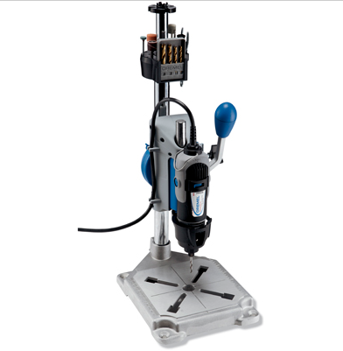

* **Always wear safety glasses. A dust mask is recommended. Preferably use where dust and particles won‘t be an issue.**
* **Unplug the tool before setting up, making adjustments or changing bits.**
* **Securely fasten the tool to the table or bench before using.**
* **Ensure the Dremel tool is installed in the press so that the On/Off switch can be easily accessed**
* **Do not wear gloves, necktie, or loose clothing and ensure long hair is tied back.**
* **Never hold the workpiece in one hand and bring the drill down with the other, the piece will catch and be spun out of your hand possibly causing lacerations.**
* **Use a “V” block for supporting round stock such as tubing or rods.**
* **Ensure the power cord is routed away from the work area**

**Oscillating tool:**



* **Hold the oscillating tool firmly to prevent vibration or chattering. Clamp the workpiece when practical.**
* **Select the proper blade for the material to be cut, and secure the blade in the tool before plugging in the battery.**

**Saber Saw (Jigsaw):**

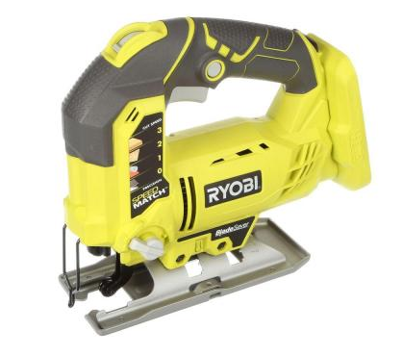

* **Select the proper blade for the material to be cut, and secure the blade in the saw before plugging in the electric cord or connecting the battery.**
* **Use a relief cut on corners to prevent binding or pinching the blade. This will prevent the blade from breaking.**
* **Hold the saber saw down firmly against the work-piece to prevent vibration or injury. Clamp the workpiece when practical. Do not hold workpiece in hand without support**
* **The saw should be placed on its’ side on the workbench when not in use.**

**Reciprocating Saw (Sawzall):**

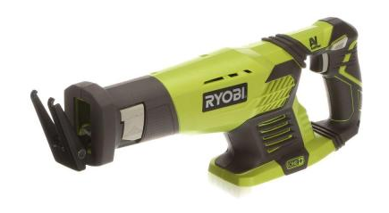

* **Select the proper blade for the material to be cut, and secure the blade in the saw before plugging in the electric cord or connecting the battery.**
* **Use a relief cut on corners to prevent binding or pinching the blade. This will prevent the blade from breaking.**
* **Hold the reciprocating saw firmly against the work-piece to prevent vibration or injury. Clamp the workpiece when practical. Do not hold workpiece in hand without support**
* **The saw should be placed on its’ side on the workbench when not in use.**

**Electric Drill:**

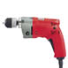

* **Particularly in metal, center punch the hole to be drilled.**
* **Tighten the drill using the chuck key or by twisting the self-tightening chuck clockwise. Remove the chuck key IMMEDIATELY.**
* **Securely clamp the work-piece before drilling. A work-piece that moves when being drilled can break the drill, injure the operator and destroy itself.**
* **Hold the drill motor firmly, and keep hands away from the revolving spindle and drill.**
* **Use a larger drill if a larger hole is needed. Using side pressure on the drill to "wobble" out the hole to increase the diameter will only damage the drill and cause it to break.**
* **Apply straight and steady pressure on the drill, and ease up on the pressure as the drill begins to break through the material.**
* **With the motor still running back out the drill as soon as the hole is drilled.**
* **Turn off the drill and hold firmly until it comes to a complete stop before laying it on the work bench.**

**Brad Nailer:**

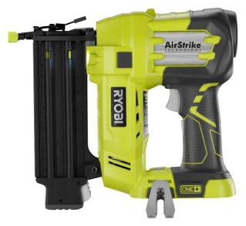

* **Always assume the tool contains nails**
* **Don’t point the tool towards yourself or anyone nearby.**